SAVEETHA SCHOOL OF ENGINEERING
SAVEETHA INSTITUTE OF MEDICAL AND TECHNICAL SCIENCES
DEPARTMENT OF COMPUTER SCIENCE AND ENGINEERING

ASSIGNMENT – 1
CSA47 – DEEP LEARNING
CO1 – MATHEMATICAL FOUNDATIONS AND MACHINE LEARNING PRINCIPLES
Submitted by: K Sujith Sai Vighnesh
Register Number: 192311199
Course Code : CSA4713
Programme / Department: CSE
Institution : SIMATS
Academic Year: 2023-27
Academic Year: 2026–2027

Introduction
Machine learning systems are only as dependable as the data, mathematical assumptions and evaluation methods behind them. This assignment considers a healthcare risk-prediction scenario in which a hospital wants to study patient age, blood pressure, glucose level, cholesterol and family history. Some patient records contain known disease labels, while other records do not. The challenge is therefore not simply to build a model; it is to understand how patient information should be represented, how uncertainty should be measured, and how different learning methods can be selected responsibly.
The answers below follow the twelve tasks in the assignment sheet. Numerical examples are shown step by step so that the calculations can be checked. Where the question does not provide actual patient measurements, a small illustrative dataset is introduced and clearly identified as an example. In a real hospital, the values, thresholds and model decisions would need to be validated using approved clinical data and medical expertise.
Note on examples: The assignment gives exact numerical information for several tasks, and those values are used directly. For Tasks 1 and 2, where the sheet does not give complete patient measurements or weights, clearly labelled illustrative values are used to show the required calculations. These examples are not presented as actual hospital data.

Rubric alignment and mark distribution
Original question focus: A hospital records age, blood pressure, glucose level and cholesterol for three patients. (a) Explain the likely effect of using the raw features without centering or normalization. (b) Represent the patient data as a feature matrix and apply a suitable normalization procedure using a small numerical example. (c) Explain why normalization is important for distance-based and gradient-based learning methods.

(a) Effect of using raw features without centering or normalization
The four measurements in the scenario—age, blood pressure, glucose and cholesterol—are recorded on different numerical scales. Age may range from a few years to more than one hundred years, blood pressure is commonly expressed in tens or hundreds, and glucose and cholesterol are also measured using their own units and ranges. When these values are supplied directly to a learning algorithm, the features with larger numerical ranges can have a stronger influence on calculations, even when they are not medically more important.
For example, imagine that the difference in age between two patients is 20, while their glucose values differ by only 10. A distance-based algorithm may treat the age difference as larger simply because the numerical difference is larger. This does not mean age is necessarily more important than glucose; it is a consequence of the units and scales used to record the data. In gradient-based learning, features with very different scales can also produce an uneven optimization landscape. The model may take inefficient steps during training, converge slowly, or require careful adjustment of the learning rate.
Not centering the data can also make optimization less convenient. Centering generally means subtracting a feature's mean so that the transformed feature has an average close to zero. It can reduce unnecessary offsets and make some optimization procedures behave more smoothly. However, centering and scaling are not exactly the same operation: centering shifts the values, while scaling changes their spread or range.
- Large-range features may dominate distance calculations.
- Gradient updates may be poorly balanced across features.
- The model may need more training iterations or more careful hyperparameter tuning.
- The resulting model can give a misleading impression of feature importance if scale effects are not controlled.
Therefore, raw values should not automatically be treated as comparable. The preprocessing method should be selected according to the algorithm and the meaning of each feature.

(b) Feature matrix and a suitable normalization procedure
The assignment does not provide exact measurements for the three patients. The following small dataset is therefore used only to demonstrate the method. The columns are ordered as age, systolic blood pressure, glucose and cholesterol.
Patient | Age (years) | BP (mmHg) | Glucose | Cholesterol
P1 | 25 | 110 | 90 | 180
P2 | 50 | 130 | 120 | 220
P3 | 75 | 150 | 150 | 260
The feature matrix X is:
X = [[25, 110, 90, 180], [50, 130, 120, 220], [75, 150, 150, 260]]
One suitable method for this example is min–max normalization. It maps each feature to a value between 0 and 1 using the minimum and maximum observed values for that feature.
x' = (x − x_min) / (x_max − x_min)
The calculation is performed separately for every column. For age, the minimum is 25 and the maximum is 75. Thus, the normalized age values are: (25−25)/(75−25) = 0, (50−25)/50 = 0.5, and (75−25)/50 = 1. The same process is repeated for blood pressure, glucose and cholesterol.
Patient | Age′ | BP′ | Glucose′ | Cholesterol′
P1 | 0.00 | 0.00 | 0.00 | 0.00
P2 | 0.50 | 0.50 | 0.50 | 0.50
P3 | 1.00 | 1.00 | 1.00 | 1.00
In this deliberately simple example, all three features increase in evenly spaced steps, so the normalized values happen to match. In a real dataset, the normalized values would not usually be identical across columns. The numerical verification is straightforward: every column's minimum becomes 0, its maximum becomes 1, and the middle observation becomes 0.5 for this example.
Min–max normalization is useful when a bounded scale is desired. Standardization is another common option: it subtracts the feature mean and divides by the standard deviation, producing a feature with mean approximately 0 and standard deviation approximately 1. The choice depends on the data distribution and the model. For real deployment, normalization parameters must be calculated from the training set only and then reused for validation, test and future patient records. This avoids information leakage.

(c) Importance for distance-based and gradient-based methods
Distance-based methods, such as K-nearest neighbours (KNN) and K-means clustering, compare records using distances. If one feature has a much larger range than the others, it can dominate the distance even if all features are intended to contribute meaningfully. Normalization gives the features a more comparable numerical scale, allowing the distance measure to reflect several measurements rather than mostly one.
Gradient-based methods, including neural networks trained with gradient descent, update model parameters using derivatives of a loss function. When input features have very different scales, the gradients associated with different parameters may also have very different magnitudes. This can make optimization inefficient. Scaling the inputs often improves numerical conditioning and helps the optimizer make more balanced progress.
Normalization does not mean that every medical feature has equal clinical importance. It only controls the numerical scale. If clinical evidence indicates that a feature should receive a different weight, that should be handled separately through model design, feature selection or validated weighting—not by relying on the original measurement units.
How this result fits the hospital example: In this task, the main point is that patient measurements cannot be compared fairly just because they appear in the same row. Each measurement has its own unit and range. Normalization makes the numerical values more comparable for the algorithm, while clinical importance must still be considered separately.

Task 2 – Vector Representation and Matrix Operations
Original question focus: A hospital assigns different importance weights to age, glucose level, blood pressure and cholesterol when calculating a preliminary risk score. (a) Represent one patient's feature values and the importance weights as vectors and formulate the weighted score using vector notation. (b) Use a small numerical example to calculate the score and interpret it.

(a) Feature and weight vectors
A patient's measurements can be written as a feature vector. For this example, the order is age, glucose, blood pressure and cholesterol. A second vector contains the importance weights assigned to those features. The weighted score is the dot product of the two vectors.
x = [age, glucose, blood pressure, cholesterol]ᵀ
w = [w_age, w_glucose, w_BP, w_cholesterol]ᵀ
Risk score = wᵀx = w_age·age + w_glucose·glucose + w_BP·BP + w_cholesterol·cholesterol
If several patients are represented as rows of a matrix X, their scores can be calculated together using the matrix expression Xw. This is more efficient and concise than calculating each patient's score separately.

(b) Numerical example and interpretation
To keep the example meaningful, assume that the feature values have already been normalized to a 0–1 range. Consider one patient with age = 0.60, glucose = 0.80, blood pressure = 0.70 and cholesterol = 0.50. Suppose the illustrative weights are 0.20, 0.40, 0.25 and 0.15 respectively. The weights add up to 1.
x = [0.60, 0.80, 0.70, 0.50]ᵀ
w = [0.20, 0.40, 0.25, 0.15]ᵀ
wᵀx = (0.20×0.60) + (0.40×0.80) + (0.25×0.70) + (0.15×0.50)
= 0.12 + 0.32 + 0.175 + 0.075 = 0.69
The preliminary weighted score is 0.69, or 69% if it is displayed on a 0–100 presentation scale. It indicates the combined score produced by the chosen weights and example inputs. It is not a medically validated probability of disease and should not be interpreted as a diagnosis. In a real system, weights would need to be learned from representative data or justified by validated clinical knowledge, and the score would need to be calibrated and evaluated.
How this result fits the hospital example: The vector form is useful because it turns a weighted calculation into one compact mathematical operation. The result depends on both the patient's feature values and the selected weights. Since the weights in this example are assumed for demonstration, the score should be treated as a preliminary numerical illustration, not as a real medical risk probability.

Task 3 – Probability and Conditional Probability
Original question focus: In a sample of 1,000 patients, 200 have a particular disease. Of these diseased patients, 160 have elevated glucose. Among the 800 patients without the disease, 120 have elevated glucose. (a) Calculate the probability that a randomly selected patient has elevated glucose. (b) Calculate the probability that a patient has the disease given elevated glucose. (c) Calculate the probability that a patient has elevated glucose given that the patient has the disease. (d) Explain how conditional probability can support the prioritization of patients for further testing.

Event definitions
Let D represent the event that a randomly selected patient has the disease. Let G represent the event that the patient has elevated glucose. There are 1,000 patients in total. Of these, 200 have the disease and 800 do not. Among the 200 diseased patients, 160 have elevated glucose. Among the 800 disease-free patients, 120 have elevated glucose.
Patient group | Elevated glucose | Not elevated | Total
Disease present | 160 | 40 | 200
Disease absent | 120 | 680 | 800
Total | 280 | 720 | 1000

(a) Probability that a randomly selected patient has elevated glucose
The total number of patients with elevated glucose is 160 + 120 = 280. Probability is the number of favourable outcomes divided by the total number of outcomes.
P(G) = 280 / 1000 = 0.28 = 28%
Therefore, the probability that a randomly selected patient from this sample has elevated glucose is 28%.

(b) Probability of disease given elevated glucose
This question asks us to consider only the patients whose glucose is elevated. There are 280 such patients, and 160 of them have the disease. Using conditional probability:
P(D|G) = P(D ∩ G) / P(G) = 160 / 280 = 0.5714 ≈ 57.14%
Among patients with elevated glucose in this sample, approximately 57.14% have the disease. This is a conditional probability, not the overall disease prevalence.

(c) Probability of elevated glucose given disease
Here the condition is reversed: we consider only patients who have the disease. Of the 200 diseased patients, 160 have elevated glucose.
P(G|D) = 160 / 200 = 0.80 = 80%
Thus, 80% of the patients who have the disease in this sample also have elevated glucose.

(d) Use of conditional probability in prioritizing patients
Conditional probability helps healthcare teams understand how strongly a particular observation is associated with a condition within a defined group. In this example, elevated glucose occurs in 80% of the diseased patients, while the probability of disease among patients with elevated glucose is about 57.14%. These are two different questions and should not be confused.
A hospital could use such information as one part of a screening workflow. Patients with elevated glucose may be flagged for a closer review of their complete medical history, repeat measurements or further clinical testing, depending on approved guidelines. The result can help prioritize attention when resources are limited, but it should not be used as a standalone diagnosis. Other conditions, medications, age, measurement timing and individual clinical circumstances can affect glucose levels. A clinician must interpret the result alongside other evidence.
How this result fits the hospital example: The two conditional probabilities answer different questions. P(D|G) starts with the patients whose glucose is elevated, while P(G|D) starts with patients who have the disease. Keeping the denominator clear is the easiest way to avoid mixing them up.

Task 4 – Bayesian Statistics for Disease Classification
Original question focus: A disease affects 10% of a population. A test is positive for 90% of patients who have the disease and for 5% of patients who do not have it. (a) Using Bayes' theorem, calculate the probability that a patient has the disease given a positive test result. (b) Explain the roles of prior probability and likelihood in the posterior probability. (c) Discuss why Bayesian reasoning is useful when medical information is uncertain.

(a) Probability of disease given a positive test
The disease prevalence is 10%, the test is positive for 90% of people who have the disease, and the test is positive for 5% of people who do not have it. Define D as disease and + as a positive test.
P(D) = 0.10; P(not D) = 0.90
P(+|D) = 0.90; P(+|not D) = 0.05
Bayes' theorem combines the prior probability of disease with the probability of observing a positive result under each condition:
P(D|+) = [P(+|D) × P(D)] / P(+)
P(+) = P(+|D)P(D) + P(+|not D)P(not D)
P(+) = (0.90×0.10) + (0.05×0.90) = 0.09 + 0.045 = 0.135
P(D|+) = 0.09 / 0.135 = 0.6667 ≈ 66.67%
The probability that a patient has the disease after receiving a positive result is approximately 66.67%, based on the assumptions in the question. This means that a positive result raises the estimated probability from the prior prevalence of 10% to about 66.67%, but it does not make the probability 100%.

(b) Roles of prior probability and likelihood
The prior probability is the estimate of disease probability before considering the current test result. In this question, the prior is 10%, representing the assumed prevalence in the population. The likelihood describes how probable the observed evidence is under a particular condition. Here, P(+|D) = 90% is the likelihood of a positive result for a person who has the disease, while P(+|not D) = 5% is the false-positive rate.
The posterior probability is the updated estimate after the evidence is taken into account. Bayes' theorem makes the update explicit. A test result is therefore interpreted in the context of how common the disease is and how accurately the test behaves, rather than in isolation.

(c) Why Bayesian reasoning is useful in uncertain medical settings
Medical decisions often involve incomplete information. A patient may have symptoms, risk factors, family history and test results that each provide only partial evidence. Bayesian reasoning offers a systematic way to update an estimate as new information becomes available. A clinician can begin with a prior estimate based on relevant population information and then revise it using the likelihood of observed findings.
It is particularly useful when the same test result has different meanings in populations with different disease prevalence. It also makes uncertainty visible: the result is a probability, not an absolute statement. However, the calculation is only as reliable as its inputs. Prevalence estimates must match the population being assessed, and sensitivity and specificity should come from appropriate validation studies. Bayesian calculations support clinical reasoning; they do not replace professional judgment.
How this result fits the hospital example: The positive test result changes the initial estimate, but it does not remove uncertainty. The prior prevalence and the test's false-positive behaviour both affect the final probability. This is why a test result should be interpreted with the population and clinical context in mind.

Task 5 – Entropy and Information Gain
Original question focus: A medical dataset contains 100 patient records: 40 are classified as high-risk and 60 as low-risk. (a) Calculate the entropy of the risk classification. (b) Explain what the entropy indicates about uncertainty. (c) Explain how information gain can help select a useful feature, such as glucose level.

(a) Entropy calculation
The dataset contains 100 patient records: 40 high-risk and 60 low-risk. The class probabilities are therefore P(high) = 0.40 and P(low) = 0.60. Entropy measures the uncertainty or impurity in a collection of class labels.
H(Y) = − Σ pᵢ log₂(pᵢ)
H(Y) = −[0.40 log₂(0.40) + 0.60 log₂(0.60)]
= −[0.40(−1.3219) + 0.60(−0.7370)]
= 0.5288 + 0.4422 = 0.9710 bits (approximately)
The entropy of the risk classification is approximately 0.971 bits.

(b) Meaning of entropy
Entropy describes how uncertain the class label is before using an additional feature to divide the records. If all records belonged to one class, entropy would be zero because there would be no uncertainty about the label. If the classes were evenly divided between high-risk and low-risk, entropy would be one bit for a binary classification problem, which is the maximum possible uncertainty. The value of about 0.971 is close to one, indicating that the two classes are fairly balanced and that the original dataset has substantial class uncertainty.

(c) How information gain selects a useful feature
Information gain measures how much a feature reduces entropy after the dataset is split according to that feature. For example, a decision tree may examine whether glucose is below or above a selected threshold. It calculates the entropy in each resulting group and takes the weighted average. The information gain is the original entropy minus this weighted average.
Information Gain = H(parent) − Σ (|child| / |parent|) × H(child)
If splitting on glucose produces groups in which high-risk and low-risk records are more clearly separated, the weighted child entropy will be lower and the information gain will be higher. A feature that barely changes the class mixture will have little information gain. This gives a decision tree a mathematical way to select useful splits. The selected feature should still be checked for data leakage, bias and clinical relevance; a high information-gain feature is not automatically a cause of disease.
How this result fits the hospital example: The entropy result is close to the maximum possible value for two classes, because the high-risk and low-risk groups are not far from an even split. A useful feature is one that separates these labels more clearly and reduces the uncertainty after splitting.

Task 6 – Numerical Computation and Distance Measurement
Original question focus: After normalization, Patient A is represented by (0.70, 0.80, 0.60) and Patient B by (0.50, 0.75, 0.90), using glucose, blood pressure and cholesterol features. (a) Calculate the Euclidean distance between the two patients. (b) Explain how the distance can indicate similarity between patient records. (c) Explain why normalization is necessary before comparing features with different scales.

(a) Euclidean distance calculation
Patient A is (0.70, 0.80, 0.60) and Patient B is (0.50, 0.75, 0.90), with the coordinates representing normalized glucose, blood pressure and cholesterol. The Euclidean distance between two three-dimensional points is the square root of the sum of the squared differences between corresponding coordinates.
d(A,B) = √[(0.70−0.50)² + (0.80−0.75)² + (0.60−0.90)²]
= √[(0.20)² + (0.05)² + (−0.30)²]
= √[0.0400 + 0.0025 + 0.0900]
= √0.1325 ≈ 0.364
The Euclidean distance between the two normalized patient records is approximately 0.364.

(b) Interpreting distance as similarity
A smaller distance means that the patients have more similar values across the features included in the calculation. A distance of zero would mean that the two records have exactly the same values for all three selected features. A larger distance indicates greater difference. In KNN, the distance can be used to identify nearby labelled patients and infer a class from their labels. In clustering, it can help group records that are close to one another.
Distance is always relative to the features, scaling and metric selected. Two patients may be close in glucose, blood pressure and cholesterol but differ greatly in age, family history or other clinically relevant variables that were not included in this calculation. Therefore, similarity in a mathematical feature space should not be confused with complete clinical similarity.

(c) Why normalization is needed before distance comparison
If features are measured on different scales, the feature with the largest numerical range can dominate the squared differences in Euclidean distance. This may cause the algorithm to consider two patients dissimilar mainly because of one measurement's units. Normalization places the features on comparable scales and reduces this unintended dominance. It makes the distance more balanced, although feature weighting may still be required if clinical or statistical evidence supports different contributions.
How this result fits the hospital example: The calculated distance summarizes differences in the three selected normalized measurements. It is useful for comparing records in a feature space, but it does not include every part of a patient's medical condition. The choice of features and scaling therefore affects what similarity means.

Task 7 – Bias–Variance Trade-off
Original question focus: Three disease-risk models are evaluated. Model A has high training and validation error. Model B has very low training error but high validation error. Model C has low and similar training and validation errors. (a) Identify which model has high bias and which has high variance. (b) Explain how model complexity affects bias and variance. (c) Suggest a suitable improvement for Models A and B.

(a) Identifying high bias and high variance
Model A has high training error and high validation error. This is a typical sign of underfitting and high bias: the model is not flexible enough, or has not learned sufficiently, to capture the patterns in the training data.
Model B has very low training error but high validation error. This is a typical sign of overfitting and high variance. It has learned the training examples very closely, including noise or accidental patterns, but does not perform well on new data.
Model C has low and similar training and validation errors. This suggests that it has learned useful patterns and generalizes more consistently to unseen examples. It is the most desirable of the three based on the information given.

(b) Effect of model complexity on bias and variance
Model complexity refers to how flexible a model is in representing relationships between input features and outputs. A very simple model may be unable to represent important nonlinear relationships, resulting in high bias. As complexity increases, the model can capture more detailed patterns and training error often decreases. However, a highly flexible model may also fit random fluctuations in the training sample. Its predictions then become more sensitive to which examples were used for training, increasing variance.
The bias–variance trade-off is the need to balance these two sources of error. The goal is not to minimize training error alone. The goal is to achieve low error on new patients drawn from the same relevant population. Validation data helps estimate whether additional complexity is improving generalization or simply memorizing the training set.

(c) Improvements for Models A and B
For Model A, the hospital could consider a more expressive model, add informative features, improve feature engineering, or reduce excessive regularization. It should also check whether the data are correctly preprocessed and whether the model has been trained adequately. Increasing complexity should be done gradually and measured on validation data.
For Model B, the hospital could reduce model complexity, increase regularization, use early stopping, obtain more representative training data, or apply cross-validation for more reliable model selection. Data augmentation may be relevant for certain data types, but it must preserve clinical meaning. The final choice should be based on validation performance and not merely on a lower training error.
How this result fits the hospital example: Model A appears too simple for the patterns in the data, while Model B appears to fit the training examples too closely. Model C has the most balanced behaviour based on the information given. Validation performance is important because the real aim is to predict new patients.

Task 8 – Overfitting, Underfitting and Model Capacity
Original question focus: A simple model fails to capture disease patterns, a moderately complex model performs consistently, and a highly complex model performs almost perfectly on training data but poorly on unseen patients. (a) Identify underfitting, appropriate generalization and overfitting. (b) Explain how model capacity affects the ability to learn complex relationships. (c) Explain why increasing capacity may first improve performance but later cause overfitting.

(a) Identifying the three behaviours
The simple model that fails to capture disease patterns is underfitting. It has insufficient effective capacity to learn the relationships present in the data, so its performance is poor even on the examples used for training.
The moderately complex model that performs consistently represents appropriate generalization. It has enough capacity to learn meaningful patterns while retaining good performance on unseen patients.
The highly complex model that performs almost perfectly on training data but poorly on unseen patients is overfitting. It has learned details specific to the training set that do not transfer reliably to new records.

(b) How model capacity affects learning
Model capacity is the range or complexity of functions a model can represent. A low-capacity model may only learn simple relationships. A higher-capacity model can represent more complicated patterns, interactions and nonlinear effects. For example, disease risk may depend not only on glucose by itself but also on how glucose interacts with age, blood pressure and other measurements. A model with suitable capacity may capture such relationships.
Capacity must be matched to the amount and quality of available data. If a model is too simple, it misses genuine structure. If it is too complex for the available evidence, it may fit noise, errors or unusual cases. Regularization, validation, careful feature selection and sufficient representative data help control this risk.

(c) Why increasing capacity can first help and then hurt
At the beginning, increasing model capacity often improves performance because the model can represent relationships that the simpler model could not learn. Training and validation errors may both decrease. After a certain point, additional flexibility can allow the model to fit noise and individual peculiarities in the training set. Training error may continue to fall, while validation error begins to rise. This is the point at which overfitting becomes a concern.
A practical approach is to compare several model capacities using a separate validation set or cross-validation. The selected model should be the one that performs reliably on data not used to fit its parameters. In a healthcare context, this evaluation should also consider sensitivity, specificity, calibration and the consequences of false-negative and false-positive predictions.
How this result fits the hospital example: The examples show that a model should have enough capacity to learn meaningful relationships but should not be so flexible that it memorizes the training set. A good model is judged by how well it works on unseen records, not only by how closely it fits the training data.

Task 9 – Supervised Learning and Model Evaluation
Original question focus: A hospital has historical patient records labelled as diseased or disease-free and wants to predict outcomes for new patients. (a) Explain why this is a supervised learning problem. (b) Describe the roles of training and testing sets. (c) If 92 of 100 test patients are classified correctly, calculate accuracy and interpret it.

(a) Why the task is supervised learning
The hospital has historical patient records with known labels: diseased or disease-free. These labels provide the expected output for each training example. A supervised learning algorithm uses the input measurements and their corresponding labels to learn a mapping from patient features to disease status. Once trained and evaluated, the model can estimate the likely class for a new patient whose outcome is not yet known.

(b) Roles of training and testing sets
The training set is used to fit the model. The algorithm examines the input features and known outcomes and adjusts its internal parameters to reduce prediction error. A validation set, when used, helps select model settings, compare candidate models and decide when to stop training.
The testing set is kept separate from the model-building process. It is used at the end to estimate how well the chosen model performs on data it has not seen during training or tuning. If the test set is repeatedly used to make design decisions, it gradually becomes part of the development process and no longer provides an unbiased final assessment. For patient data, splitting should also be designed carefully to avoid having records from the same person or near-duplicate encounters in both training and test sets.

(c) Accuracy calculation
The model correctly classifies 92 out of 100 test patients.
Accuracy = (Number of correct predictions / Total predictions) × 100
Accuracy = (92 / 100) × 100 = 92%
The model's accuracy on this test sample is 92%. In other words, it classified 92 of the 100 test records correctly and made 8 incorrect predictions. Accuracy is useful as a basic summary, but it may be misleading when one class is much more common than the other. For healthcare evaluation, the hospital should also examine sensitivity (recall for diseased patients), specificity, precision, F1-score, confusion matrix and probability calibration. The cost of missing a patient who has the disease may be different from the cost of incorrectly flagging a disease-free patient.
How this result fits the hospital example: The labels in the historical records provide the correct outcomes needed for supervised learning. A separate test set gives a fairer estimate of performance on new records. The 92% accuracy is useful, but other measures are needed if the disease classes are imbalanced or the types of errors have different consequences.

Task 10 – Unsupervised Learning and Patient Grouping
Original question focus: A hospital has patient records containing age, blood pressure, glucose and cholesterol but no predefined risk labels. (a) Explain why unsupervised learning is suitable. (b) Describe how K-means can group patients with similar characteristics. (c) Explain how distance can be used to measure similarity. (d) Describe how the clusters could support further clinical investigation without replacing medical diagnosis.

(a) Why unsupervised learning is suitable
The hospital has measurements for each patient but does not have predefined risk labels. Since there is no known target class for the algorithm to learn, this is an unsupervised learning problem. The purpose is to explore the structure of the records and discover groups or patterns based on similarities in the available measurements.

(b) How K-means can group patients
K-means is a clustering algorithm that divides observations into K groups. Each group is represented by a centroid, which is the mean position of the records assigned to that cluster. The algorithm aims to keep records close to their assigned centroid.
- Choose the number of clusters, K. This may be explored using domain knowledge and validation techniques such as the elbow method or silhouette score.
- Initialize K centroids, either randomly or using a method such as K-means++.
- Assign each patient record to the nearest centroid using the selected distance measure.
- Recalculate each centroid as the mean of the records assigned to that cluster.
- Repeat assignment and centroid updates until the assignments or centroid positions change very little, or a stopping condition is reached.
For this hospital scenario, K-means could identify groups with relatively similar age, blood pressure, glucose and cholesterol profiles. The clusters might reveal common patterns that deserve further investigation. The algorithm does not know what a disease diagnosis means unless clinical labels and interpretation are added separately.

(c) Distance as a measure of similarity
K-means commonly uses Euclidean distance to compare a patient record with each cluster centroid. The record is assigned to the cluster whose centroid is nearest. A short distance indicates that the patient's feature values are relatively close to the typical values of that cluster. A long distance indicates that the patient is less typical of that cluster.
Because K-means is distance-based, the input features should generally be scaled appropriately. Otherwise, a feature with a larger numerical range can dominate the assignment. The hospital should also examine outliers and consider whether Euclidean distance is suitable for the data.

(d) Clinical use of clusters without replacing diagnosis
Clusters can support exploratory analysis by helping clinicians and analysts identify patient subgroups that may share risk-factor patterns. For example, one cluster might contain records with comparatively high glucose and cholesterol, while another might contain older patients with elevated blood pressure. The hospital could investigate whether these groups differ in later outcomes, follow-up needs or service utilization.
These are patterns in the available data, not medical diagnoses. Clustering can be affected by feature selection, scaling, missing values and the chosen number of clusters. Clinical experts must review whether the groups are meaningful, safe and useful before any operational use. A patient's cluster should never be treated as proof that the patient has a disease.
How this result fits the hospital example: K-means can organize patients according to similarities in the selected measurements. The resulting groups can help analysts notice patterns that deserve further study. However, a cluster is not a diagnosis and should not be used as a substitute for a clinician's assessment.

Task 11 – Comparison of Supervised and Unsupervised Learning
Original question focus: Dataset A contains patient features with disease labels, while Dataset B contains patient features without labels. (a) Identify the suitable learning paradigm for each dataset and justify your choice. (b) Compare their objectives and outputs. (c) Recommend an approach for predicting disease status in a new patient and justify the recommendation.

(a) Suitable learning paradigm for each dataset
Dataset A contains patient features together with disease labels. Supervised learning is suitable because the known labels provide target outcomes from which a classifier can learn. The objective is to predict disease status for records whose labels are not yet known.
Dataset B contains patient features but no labels. Unsupervised learning is suitable for discovering structure, such as clusters of patients with similar characteristics. Since there are no predefined disease outcomes, the algorithm cannot directly learn a disease classifier from Dataset B alone.

(b) Objectives and outputs
Aspect | Supervised learning | Unsupervised learning
Input data | Features with known labels | Features without predefined labels
Main objective | Learn to predict a target outcome | Discover structure or similarity
Typical methods | Logistic regression, decision tree, random forest, neural network | K-means, hierarchical clustering, dimensionality reduction
Typical output | Predicted class or probability | Cluster assignment, groups or latent structure
Evaluation | Accuracy, sensitivity, specificity, AUC, calibration | Silhouette score, cluster stability and domain interpretation
The central difference is that supervised learning has a target answer during training, whereas unsupervised learning tries to find useful organization without being given the correct group for each record.

(c) Recommended approach for predicting a new patient's disease status
For the specific goal of predicting whether a new patient has the disease, a supervised classifier trained on Dataset A is the most direct choice because Dataset A contains the required disease labels. The model can learn from examples where the outcome is known and then produce a predicted class or risk probability for a new patient.
Dataset B should not be ignored. It may be used for exploratory clustering, understanding the wider patient population, identifying unusual records or informing future data collection. If the hospital later has a carefully designed method for using unlabelled data alongside labelled data, semi-supervised learning could also be investigated. However, the final disease prediction system must be evaluated against reliable labelled outcomes. Clusters alone do not establish whether a patient has a disease.
How this result fits the hospital example: Dataset A directly supports supervised prediction because it contains disease labels. Dataset B can help reveal groups and structure, but it cannot independently teach the model which patients have the disease. The two approaches can be used together for their different purposes.

Task 12 – Design Challenge: Selecting and Adapting a Learning Strategy
Original question focus: The hospital initially analyzes 10,000 patient records. It must now process 1,000,000 records, predict disease risk, discover patient groups, and handle missing values and differences in feature scales. Decide whether to retain, modify or redesign the analytical strategy. A. Impact Analysis: explain the effect of increasing dataset size on data representation, numerical computation and learning efficiency; discuss normalization, missing-value handling and data variability. B. Evaluation of the Original Approach: evaluate whether one supervised approach is sufficient for both disease prediction and patient-group discovery; explain limitations of labelled learning when useful patterns also exist in unlabelled records. C. Adaptation or Redesign: propose a strategy combining supervised classification and unsupervised clustering; explain how probability, distance measures, normalization and model capacity can be incorporated. D. Evidence-Based Defence: propose experiments and evaluation measures to compare the redesigned approach with the original; justify the final design using mathematical reasoning, generalization, computational needs and data characteristics.
The hospital's requirement has expanded from 10,000 to 1,000,000 patient records. The system must predict disease risk, discover patient groups and manage missing values and different feature scales. This is a substantial change in both data volume and analytical objectives. A single model is unlikely to meet every requirement effectively. The recommended decision is to modify and extend the original strategy into a combined analytical pipeline.

A. Impact Analysis

(a) Effect of increasing the dataset size
Increasing the dataset from 10,000 to 1,000,000 records means processing one hundred times as many observations. The feature matrix becomes much larger, so storage, memory use, data transfer and computation time all increase. If each record contains several measurements, identifiers, timestamps and labels, the complete dataset may require substantial storage and careful data management.
A larger dataset can improve learning because it may represent more patient groups, a wider range of measurements and less common combinations of risk factors. It can help reduce sampling uncertainty when the records are representative and of good quality. However, more data do not automatically guarantee a better model. Duplicates, measurement errors, missing values, inconsistent units and population bias can also become more prominent.
Numerical computation must be planned for scale. Matrix operations, distance calculations and model training may become more expensive. The hospital can use efficient data types, vectorized operations, database filtering, mini-batch training and scalable processing frameworks where appropriate. Clustering one million records may require more computation than clustering a small sample, particularly if many clusters or repeated restarts are evaluated.

(b) Importance of normalization, missing-value handling and variability
Normalization is important because patient measurements use different units and ranges. It supports fairer distance calculations and can improve the optimization of many machine-learning models. The transformation must be fitted on training data and consistently applied to later data.
Missing-value handling is equally important. A missing glucose result should not automatically be treated as zero, because zero may have a different meaning from an unrecorded measurement. The hospital should first study why values are missing and how frequently each feature is affected. Possible approaches include removing records only when justified, imputing values using suitable statistics or models, and adding missingness indicators when the fact that a value is absent may itself carry information. Any imputation process must be fitted using training data only.
Data variability refers to the differences among patients and their measurements. A representative dataset should capture relevant age groups, clinical settings and patterns of disease. Outliers should be investigated rather than removed automatically, because some extreme values may be genuine and clinically important. The hospital should also monitor whether the data distribution changes over time or differs across patient subgroups.

B. Evaluation of the Original Approach

(a) Is one supervised approach sufficient for prediction and group discovery?
A single supervised classifier is suitable for predicting disease status when reliable labels are available, but it is not sufficient for the complete requirement. The hospital also wants to discover patient groups without predefined labels. A classifier is trained to distinguish known outcomes; it does not necessarily reveal the natural structure of the patient population. A separate unsupervised clustering method is therefore appropriate for the group-discovery objective.
The two methods can work together. The supervised component can estimate disease risk, while the unsupervised component can identify patterns among patients. Their outputs can be compared during analysis, but a cluster should not be interpreted as a diagnosis and a predicted risk should not be assumed to explain why a patient belongs to a particular group.

(b) Limitations of labelled learning when unlabelled records contain useful patterns
Supervised learning depends on the quality and quantity of labelled examples. In healthcare, obtaining reliable labels may require clinical review, diagnostic tests and follow-up, which can be costly and time-consuming. If the hospital trains only on labelled records, it may leave a large amount of potentially useful information in the unlabelled records unused.
Unlabelled records may contain patient subgroups, rare combinations of measurements or distribution changes that are not well represented in the labelled sample. A model trained only on a small or biased labelled subset may not generalize well to these records. At the same time, unlabelled data do not provide the correct disease outcome, so they cannot simply replace labels. Their role should be carefully defined and validated.

C. Adaptation or Redesign

(a) Combined supervised and unsupervised strategy
The recommended design is a two-branch learning pipeline supported by a shared data-preparation stage.
- Data ingestion: collect the labelled and unlabelled patient records from approved hospital systems, check schema consistency, remove duplicate records where appropriate and protect patient information.
- Data quality assessment: examine missingness, invalid values, outliers, units, class distribution and possible data leakage. Record the rules used for cleaning.
- Preprocessing: handle missing values, encode categorical variables where required and scale numerical features. Fit preprocessing parameters on the training data and reuse them consistently.
- Supervised branch: train a disease-risk classifier using labelled records. Compare suitable models such as logistic regression, decision trees and random forests, and select the model using validation evidence.
- Unsupervised branch: apply a clustering method such as K-means to appropriately prepared patient features. Explore the number of clusters and evaluate whether the groups are stable and interpretable.
- Integrated interpretation: examine the distribution of predicted risks across clusters. Ask whether particular clusters contain different risk profiles, while avoiding the assumption that cluster membership proves disease.
- Deployment and monitoring: evaluate the system before use, provide clinician-facing explanations and monitor model performance, data drift and subgroup differences over time.
This design retains supervised learning for the labelled prediction task and adds unsupervised learning for discovering structure in the wider dataset. It addresses both hospital objectives without forcing one algorithm to perform two different jobs.

(b) Incorporating probability, distance, normalization and model capacity
Probability can be incorporated by having the supervised classifier produce an estimated disease probability rather than only a hard class label. The hospital can then select decision thresholds based on clinical priorities and evaluate whether predicted probabilities are calibrated. Bayesian reasoning may also be used to update risk estimates when appropriate prior information and validated likelihoods are available.
Distance measures are central to clustering. For K-means, Euclidean distance can be calculated between a patient and each cluster centroid. The distance metric should be selected with the feature types and clinical meaning in mind. If the dataset includes categorical variables or strongly correlated features, a different distance or clustering approach may be more appropriate.
Normalization should be included before distance-based analysis and, where useful, before gradient-based model training. Continuous variables should be transformed consistently, and categorical variables should be encoded using a suitable method. The hospital should retain the fitted preprocessing pipeline so new records are transformed exactly as the training data were.
Model capacity should be controlled using validation. The hospital can compare simple and more flexible classifiers, use regularization and cross-validation, and select a model that performs well on unseen records. For clustering, it can compare different values of K and examine silhouette scores, cluster stability and clinical interpretability. Greater complexity should be accepted only when it produces a meaningful and reproducible improvement.

D. Evidence-Based Defence

(a) Experiments and evaluation measures
The redesigned strategy should be compared with the original approach through a planned set of experiments. The same carefully prepared data partitions should be used for fair comparisons, and the test set should remain untouched until final evaluation.
- Experiment 1 – Baseline classifier: train the original supervised model using labelled records and record its performance.
- Experiment 2 – Alternative classifiers: compare models such as logistic regression, decision tree and random forest using the same training and validation partitions.
- Experiment 3 – Preprocessing comparison: compare justified preprocessing choices, including scaling methods and missing-value strategies, while preventing information leakage.
- Experiment 4 – Clustering analysis: run K-means for a range of K values and compare inertia, silhouette score, stability and the interpretability of the resulting groups.
- Experiment 5 – Combined analysis: examine predicted risk distributions across clusters and determine whether the clusters reveal additional structure that is useful for further investigation.
- Experiment 6 – Scale and efficiency: measure training time, prediction time, memory consumption and the ability to process the full one-million-record dataset.
For disease prediction, evaluation should include accuracy, precision, recall or sensitivity, specificity, F1-score, ROC-AUC and a confusion matrix. Calibration measures such as the Brier score can help assess whether predicted probabilities correspond to observed outcomes. In healthcare, sensitivity and specificity are especially important because false negatives and false positives can have different consequences.
For clustering, the hospital can use the silhouette score to assess separation and cohesion, inertia to understand within-cluster variation, and repeated runs or resampling to assess stability. Numerical metrics should be combined with clinical review because a mathematically compact cluster may not be clinically meaningful. Efficiency measures such as runtime and memory use are also necessary at this scale.

(b) Justification of the final design
The combined design is justified because the hospital has two distinct analytical goals. Disease-risk prediction requires labelled examples and is therefore addressed by supervised classification. Patient-group discovery does not require predefined labels and is addressed by unsupervised clustering. Keeping these objectives in separate but connected branches makes the purpose of each output clear.
Mathematically, normalization reduces the risk that measurement units dominate distance calculations, while probability provides a principled way to express uncertainty in disease-risk estimates. Distance measures support the grouping of similar records. Model-capacity control and validation help balance bias and variance so that the classifier generalizes beyond its training data.
From a computational perspective, one million records require efficient preprocessing, storage and training. The hospital should use scalable implementations, monitor memory and runtime, and consider mini-batch or other scalable clustering methods if ordinary K-means becomes too expensive. The final system should be designed as a reproducible pipeline rather than a collection of disconnected scripts.
Finally, the quality and representativeness of the data remain essential. Missing values, inconsistent measurements, outliers and changes in the patient population can affect both branches. The model should therefore be validated on appropriately separated data, reviewed across relevant patient subgroups and monitored after deployment. The system should assist healthcare professionals by organizing evidence and highlighting cases for review; it should not independently make a medical diagnosis or replace clinical judgment.
How this result fits the hospital example: The revised design uses supervised learning for disease prediction and unsupervised learning for patient-group discovery. It also adds stronger data preparation and performance checks because the dataset is much larger. This approach is more suitable than expecting one algorithm to answer both questions.

Conclusion
This assignment demonstrates how mathematical foundations guide the design of reliable learning systems in a healthcare setting. Feature matrices and vectors provide a structured representation of patient information, while normalization helps prevent differences in measurement scale from distorting learning. Probability and conditional probability describe how frequently events occur and how evidence changes the interpretation of risk. Bayes' theorem updates prior beliefs using test evidence, and entropy and information gain explain how a feature can reduce uncertainty during classification.
The bias–variance trade-off, model capacity, overfitting and underfitting show why a model must be evaluated on unseen data rather than judged only by its training performance. Supervised learning is appropriate when disease labels are available, whereas unsupervised learning can reveal groups in unlabelled patient records. For the expanded one-million-record requirement, a combined strategy is more suitable than relying on a single learning method. With careful preprocessing, scalable computation, independent evaluation and clinical oversight, the hospital can build an analytical system that supports better investigation while respecting the uncertainty and complexity of healthcare data.

References
1. Assignment 1, CSA47 – Deep Learning, CO1: Mathematical Foundations and Machine Learning Principles, Saveetha School of Engineering, supplied course document.
2. Goodfellow, I., Bengio, Y., and Courville, A., Deep Learning. MIT Press, 2016.
3. Bishop, C. M., Pattern Recognition and Machine Learning. Springer, 2006.
4. Murphy, K. P., Probabilistic Machine Learning: An Introduction. MIT Press, 2022.
5. James, G., Witten, D., Hastie, T., Tibshirani, R., and Taylor, J., An Introduction to Statistical Learning: with Applications in Python. Springer, 2023.
Note: The worked patient measurements and weighted-score values in Tasks 1 and 2 are illustrative examples created to demonstrate the requested calculations. They are not real patient data or clinically validated thresholds.

Visual Guide 1 – Reading a Patient Feature Matrix
A feature matrix is a structured numerical representation of a dataset. Each row represents one observation, while each column represents one feature. In this assignment, one row corresponds to one patient and the columns correspond to age, blood pressure, glucose and cholesterol. This representation allows mathematical operations to be performed consistently across many patients.
A matrix is more than a table for display. It is the form used by many machine-learning libraries to perform calculations efficiently. A model can process an entire matrix through vectorized operations instead of handling each cell manually. This becomes especially important when the hospital moves from 10,000 to 1,000,000 records.
The values in a feature matrix must be meaningful and consistently defined. If blood pressure is recorded in different units in different hospital departments, the same column no longer represents a consistent measurement. Data dictionaries, unit checks and validation rules are therefore essential before modelling.
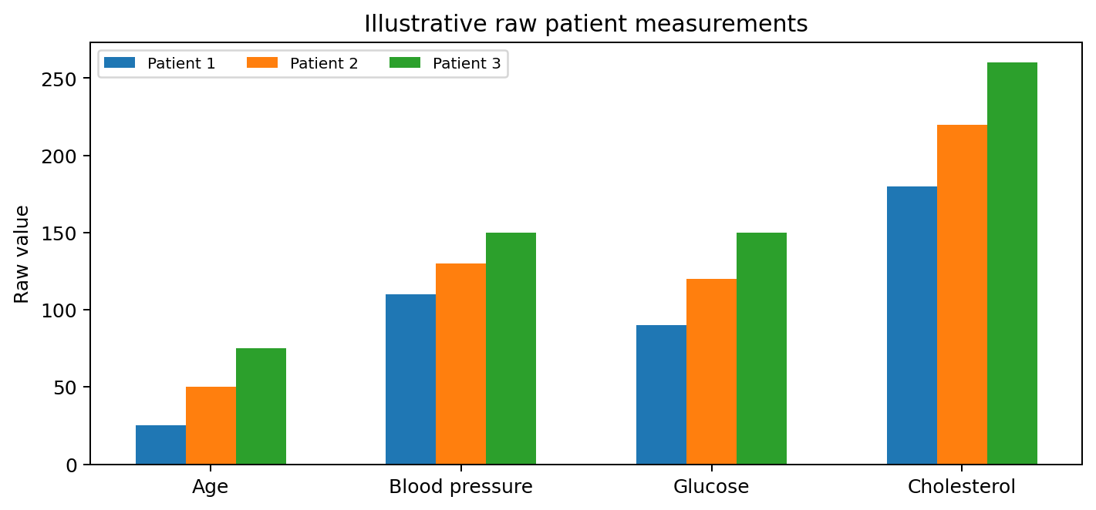
Figure 1. Raw illustrative patient measurements show why feature scales differ.
A useful data dictionary records the name of each feature, its unit, valid range, source system and missing-value convention. This makes the matrix understandable to developers, analysts and clinical reviewers.

Visual Guide 2 – Understanding Normalized Values
Min–max normalization converts each numerical feature to a common interval. It preserves the relative order of observations within a feature, but changes the numerical units. The transformation is performed independently for each column.
For the example used in Task 1, the three patient records have evenly spaced values in every column. As a result, the normalized values are 0.00, 0.50 and 1.00 for each feature. This is a deliberately simple demonstration. Real data are rarely so regular, and different features will generally produce different normalized values for the same patient.
Normalization parameters must be learned from the training data only. The minimum and maximum from the training set are then applied to validation, test and future records. This prevents information from the test set from influencing the preprocessing stage.
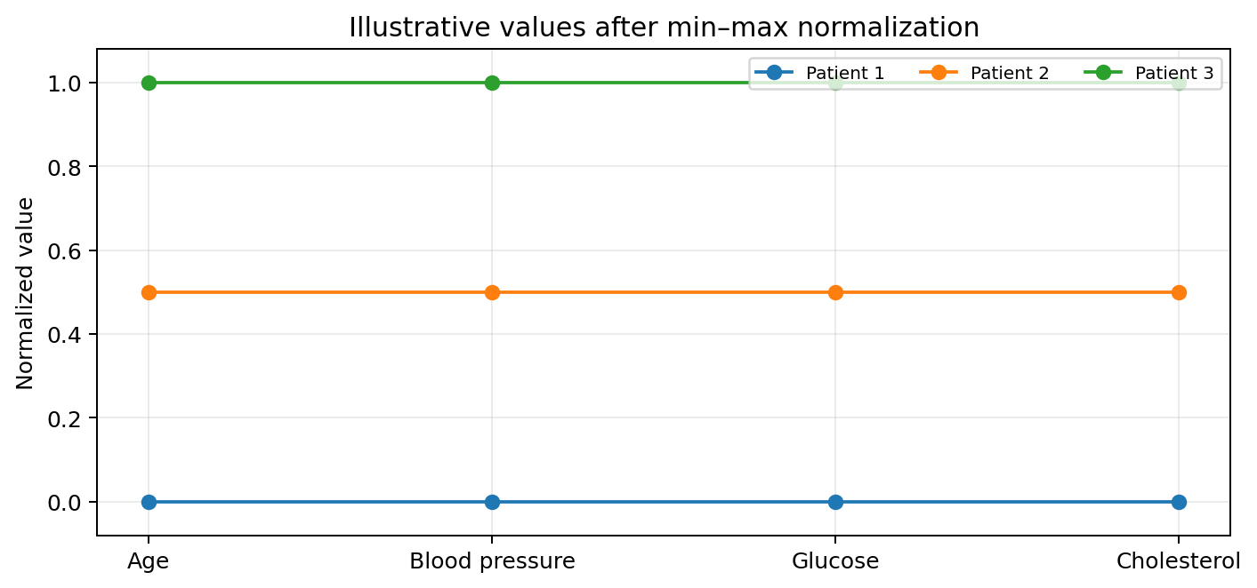
Figure 2. Illustrative patient values after min–max normalization.

Visual Guide 3 – Why Feature Scaling Matters
Distance-based algorithms calculate how far apart records are in a feature space. If one feature has a much larger numerical range than another, it can dominate the distance. For example, a difference of 30 in cholesterol may contribute more numerically than a difference of 0.2 in a normalized glucose feature, even though the comparison is not meaningful unless the scales are aligned.
Gradient-based algorithms have a related issue. Features with very different scales can lead to gradients with different magnitudes. This may slow optimization or make training sensitive to the learning rate. Scaling often improves numerical conditioning and makes optimization more manageable.
Scaling does not establish clinical importance. It only addresses numerical scale. If one feature should receive more weight, that decision requires a separate, evidence-based justification.

Visual Guide 4 – Probability Tree and Conditional Probability
The Task 3 counts can be organized into a simple tree. Out of 1,000 patients, 200 have the disease and 800 do not. Of the 200 diseased patients, 160 have elevated glucose and 40 do not. Of the 800 without disease, 120 have elevated glucose and 680 do not.
The total number with elevated glucose is 160 + 120 = 280. Therefore P(G) = 280/1000 = 0.28. The probability of disease among patients with elevated glucose is P(D|G) = 160/280 = 57.14%. The probability of elevated glucose among diseased patients is P(G|D) = 160/200 = 80%.
The distinction is important because the condition after the vertical bar determines the denominator. Conditional probability is useful for interpreting evidence, but it does not prove causation or establish an individual diagnosis.
P(D|G) = 160/280 = 57.14% and P(G|D) = 160/200 = 80%

Visual Guide 5 – Bayesian Test Interpretation
A positive medical test does not always mean that a patient has a disease. The result must be interpreted in relation to disease prevalence and test performance. In Task 4, the disease prevalence is 10%, sensitivity is 90%, and the false-positive rate is 5%.
A frequency example makes the calculation easier to understand. Among 1,000 people, 100 are expected to have the disease. A test with 90% sensitivity identifies 90 of those 100 as positive. Among the 900 people without disease, a 5% false-positive rate produces 45 additional positive results. There are 135 positive results in total, and 90 are true positives.
The posterior probability is therefore 90/135 = 66.67%. This illustrates why a test's sensitivity alone does not tell us the probability that a positive patient has the disease. The prior prevalence and false-positive rate also matter.
P(D|+) = [0.90 × 0.10] / [(0.90 × 0.10) + (0.05 × 0.90)] = 66.67%

Visual Guide 6 – Entropy and Information Gain
Entropy measures the uncertainty in a set of class labels. If every record belongs to the same class, entropy is zero. If two classes are equally represented, entropy is at its maximum for a binary classification problem. In Task 5, 40 records are high-risk and 60 are low-risk, producing entropy of approximately 0.971 bits.
A decision tree evaluates candidate features by estimating how much each split reduces entropy. A glucose threshold may divide records into groups with different proportions of high-risk labels. If the groups become more homogeneous, the weighted entropy after the split is lower and information gain is higher.
Information gain helps select a useful split, but it does not establish that the selected feature causes the outcome. It can also favour features with many possible split points, so tree-building methods may use additional safeguards.
IG = H(parent) − Σ (child size / parent size) × H(child)

Visual Guide 7 – Bias and Variance
Bias describes error caused by assumptions that are too restrictive or by a model that cannot represent the true relationship. Variance describes how much the learned model changes when the training data change. A simple model can have high bias, while an overly flexible model can have high variance.
As complexity increases, bias often decreases because the model can represent more relationships. At the same time, variance may increase because the model can fit details specific to the training sample. The combined error can be lowest at an intermediate level of complexity.
The graph is conceptual rather than a measured result from the hospital data. It explains why the hospital should compare models on validation data and should not select a model solely because it has the smallest training error.
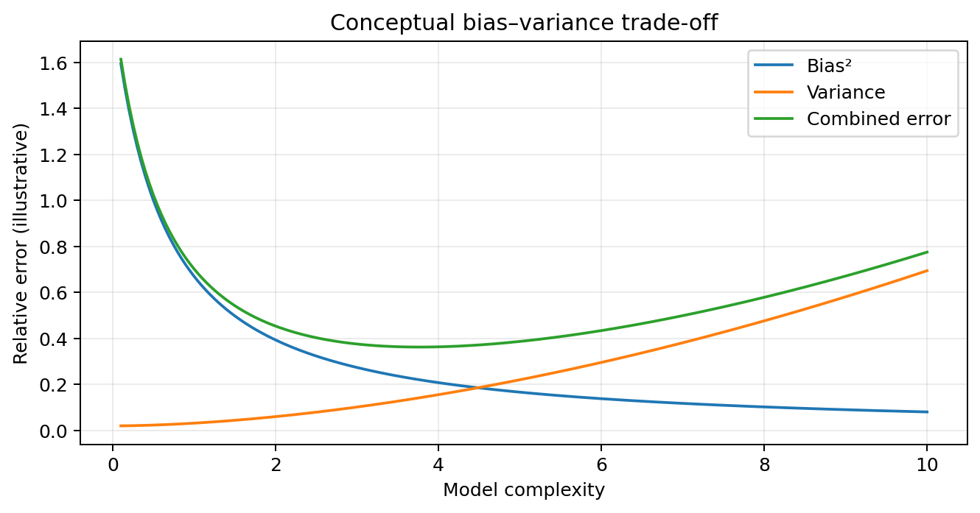
Figure 3. Conceptual bias–variance relationship; curves are illustrative.

Visual Guide 8 – K-means Clustering
K-means groups observations by assigning each record to its nearest centroid. The centroid is the mean position of all observations assigned to that cluster. The algorithm alternates between assignment and centroid-update steps until the assignments stabilize or a stopping condition is met.
The illustration shows three groups in a two-dimensional feature space. The points and centroids are synthetic and are not actual patient measurements. In the hospital dataset, clustering would usually use more than two features, and the feature scaling would need to be carefully selected.
The number of clusters, K, should be investigated. The elbow method, silhouette score, stability across repeated runs and clinical interpretability can all help. A cluster is a group of similar records, not a medical diagnosis.
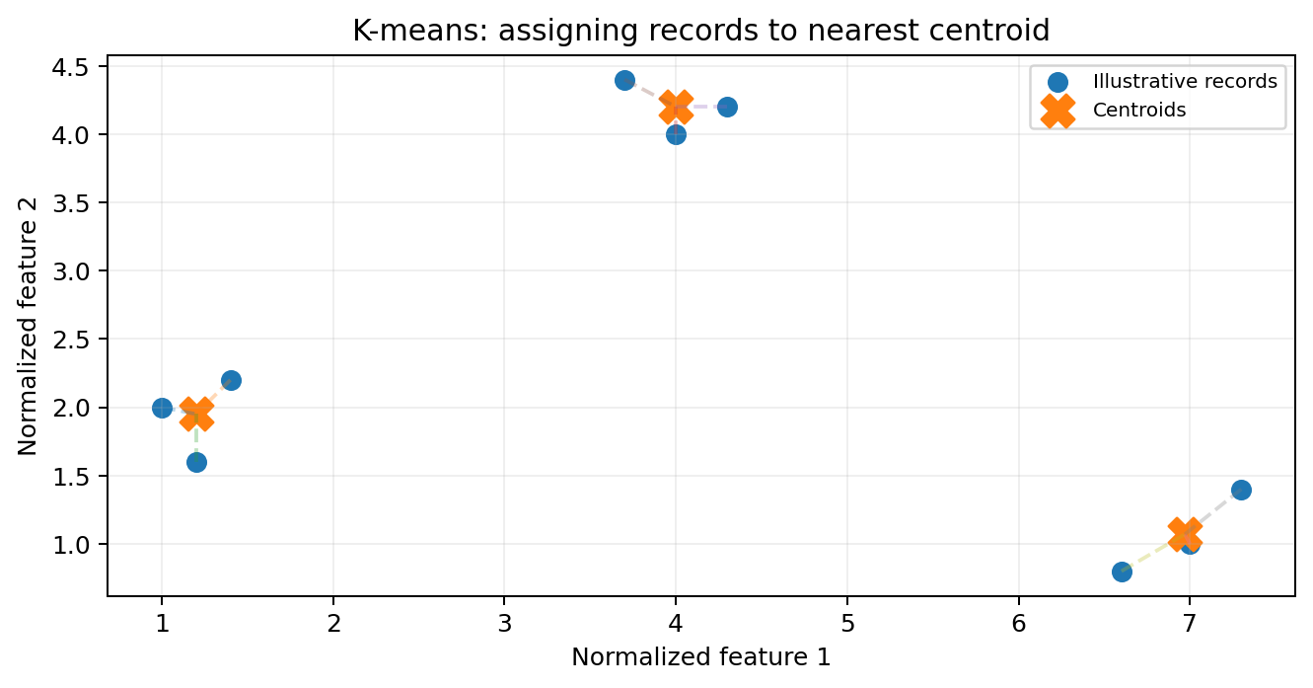
Figure 4. K-means illustration using synthetic points and centroids.

Visual Guide 9 – Confusion Matrix
A confusion matrix describes the types of predictions made by a classifier. True positives are diseased patients correctly predicted as diseased. True negatives are disease-free patients correctly predicted as disease-free. False positives are disease-free patients incorrectly flagged, while false negatives are diseased patients missed by the model.
Accuracy combines correct positive and negative predictions. Sensitivity focuses on diseased patients, while specificity focuses on disease-free patients. Precision answers how many positive predictions are correct. These measures provide different views of model performance.
The accompanying example is synthetic and is not the 92 out of 100 result in Task 9. It is included to show how a matrix supports more detailed evaluation than a single accuracy figure.
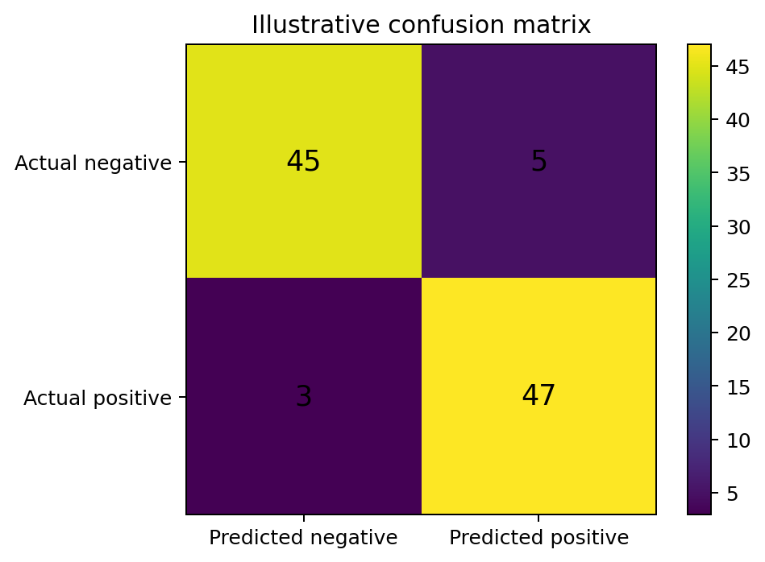
Figure 5. Example confusion matrix with synthetic counts.
Sensitivity = TP/(TP+FN) Specificity = TN/(TN+FP)

Visual Guide 10 – End-to-End Healthcare Learning Workflow
A complete analytical workflow begins with data ingestion and quality checks. The hospital should confirm that measurements have consistent definitions, investigate duplicate records and identify missing or invalid values. Preprocessing follows, including imputation and scaling where required.
The data are then divided into training, validation and test sets. The supervised branch learns to predict disease outcomes from labelled records. The unsupervised branch explores patient groups using available features, including records without labels. Both branches require evaluation and careful interpretation.
Before operational use, the system should undergo clinical review, privacy and security assessment, and monitoring design. The output should support professional review rather than replace diagnosis.
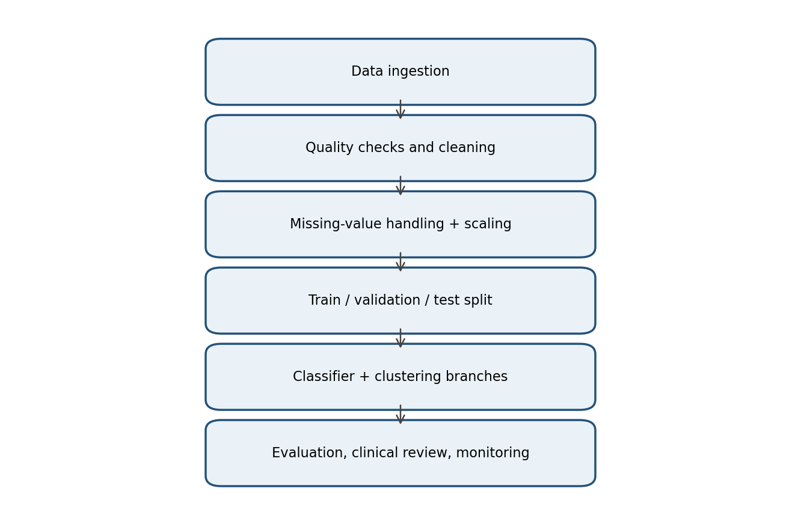
Figure 6. Suggested workflow for the expanded one-million-record requirement.

Supplementary Note 1 – Missing-Value Handling
Missing values should not automatically be replaced with zero. A missing glucose measurement is not the same as a measured glucose value of zero. The hospital should investigate how often each feature is missing and whether missingness is associated with patient groups, clinical workflows or data-transfer problems.
Possible strategies include complete-case analysis, mean or median imputation, model-based imputation and missingness indicators. Each strategy has assumptions. Removing incomplete records can reduce sample size and introduce bias. Simple imputation is easy to implement but can reduce variability. More complex imputation can preserve relationships but requires careful validation.
Any imputation parameters must be fitted on training data only. The same fitted process should be applied to validation, test and future patient records.

Supplementary Note 2 – Outliers and Data Quality
An extreme measurement may be a data-entry error, a unit mismatch or a genuine clinical observation. Automatically deleting all outliers is unsafe because rare measurements may be clinically important. A responsible process checks the source, units, plausible ranges and collection context before changing a value.
Data-quality rules should be documented. For example, the system can flag impossible ages, inconsistent units or duplicate encounters for review. A flagged record should not automatically be removed unless the rule is justified. Robust statistical methods may help reduce the influence of extreme observations, but they do not replace checking the data source.

Supplementary Note 3 – Data Leakage
Data leakage occurs when information that should be unavailable at prediction time influences model development. It may occur if preprocessing parameters are calculated using the full dataset before splitting, if test records influence feature selection, or if a variable recorded after diagnosis is used as a predictor.
To reduce leakage, split the data before fitting imputation, scaling and feature-selection steps. Keep the final test set untouched until model selection is complete. If a patient has multiple visits, design the split so that related records do not create unrealistic overlap between training and testing. For time-dependent prediction, a chronological split may better reflect real deployment.

Supplementary Note 4 – Selecting Evaluation Metrics
Accuracy is the proportion of all predictions that are correct. Sensitivity is the proportion of diseased patients correctly identified. Specificity is the proportion of disease-free patients correctly identified. Precision is the proportion of positive predictions that are truly positive. The F1-score combines precision and recall.
A hospital should not select metrics without considering the intended use. Missing a disease case may have a different consequence from requesting an unnecessary follow-up test. ROC-AUC measures ranking performance across thresholds, while calibration assesses whether predicted probabilities match observed frequencies. Evaluation should include subgroup analysis and uncertainty where possible.

Supplementary Note 5 – Responsible Healthcare Deployment
A model can assist healthcare teams by organizing information, identifying patterns and helping prioritize further review. It should not be treated as an independent medical authority. Its reliability depends on the data, the patient population, measurement practices and the environment in which it is used.
Before deployment, the hospital should validate the model, review its limitations with clinicians, assess privacy and security, and examine performance across relevant patient subgroups. After deployment, it should monitor data drift and changes in performance. Clear documentation, audit trails and a process for investigating errors are essential.

Supplementary Note 6 – Scaling to One Million Records
Moving from 10,000 to 1,000,000 records increases the number of observations by a factor of 100. Storage, memory, data transfer and computation become more demanding. Efficient matrix operations, vectorized processing, mini-batch training and scalable data pipelines can help.
A larger dataset may improve representation of patient diversity, but only if it is relevant and reliable. More records can also introduce more duplicates, missingness, inconsistent units and population bias. The hospital should benchmark runtime and memory use using data volumes representative of deployment. The final design should be reproducible and should retain a clear record of preprocessing and model versions.
- Use efficient storage formats and data types.
- Process records in batches when appropriate.
- Measure memory, runtime and prediction throughput.
- Keep preprocessing and model versions reproducible.

Supplementary Note 7 – Model Capacity and Regularization
Model capacity describes the complexity of relationships that a model can represent. A low-capacity model may fail to learn important interactions. A high-capacity model may learn complex patterns but can also fit noise. Regularization discourages unnecessarily complex solutions and can improve generalization.
The hospital can compare candidate models using validation data, tune regularization strength and use early stopping when appropriate. Cross-validation can provide a more stable estimate during model selection. The final test set should be used only once for the final performance assessment.

Supplementary Note 8 – Final Design Rationale
The combined design is appropriate because the hospital has two distinct objectives. Disease-risk prediction uses labelled records and is therefore a supervised learning task. Patient-group discovery uses unlabelled features and is therefore an unsupervised learning task. Separate branches make the purpose and limitations of each output clear.
Probability expresses uncertainty in disease-risk estimates. Distance measures support grouping. Normalization prevents measurement units from dominating numerical calculations. Model-capacity control and validation support generalization. Efficient processing addresses the larger dataset. Clinical review ensures that mathematical patterns are interpreted responsibly.

Appendix A – Formula Reference Sheet
Concept | Formula
Min–max normalization | x′ = (x − x_min)/(x_max − x_min)
Standardization | z = (x − μ)/σ
Weighted score | s = wᵀx
Probability | P(A) = favourable outcomes / total outcomes
Conditional probability | P(A|B) = P(A∩B)/P(B)
Bayes’ theorem | P(D|+) = P(+|D)P(D)/P(+)
Entropy | H(Y) = −Σ pᵢ log₂(pᵢ)
Information gain | IG = H(parent) − weighted child entropy
Euclidean distance | d(x,y) = √Σ(xᵢ−yᵢ)²
Accuracy | (TP+TN)/(TP+TN+FP+FN)
Sensitivity | TP/(TP+FN)
Specificity | TN/(TN+FP)
Precision | TP/(TP+FP)
F1-score | 2 × (Precision × Recall)/(Precision + Recall)

Appendix B – Glossary of Important Terms
Feature: A measurable input variable, such as age or glucose.
Feature matrix: A two-dimensional arrangement of observations and features.
Normalization: A transformation that places numerical features on comparable scales.
Standardization: A transformation that expresses values relative to a mean and standard deviation.
Vector: An ordered collection of numerical values.
Dot product: The sum of pairwise products of corresponding vector elements.
Prior probability: The probability assigned before considering new evidence.
Likelihood: The probability of observing evidence under a specified condition.
Posterior probability: An updated probability after evidence is considered.
Entropy: A measure of uncertainty in class labels.
Information gain: The reduction in entropy produced by a split.
Euclidean distance: Straight-line distance between points in feature space.
Bias: Error caused by overly restrictive assumptions or insufficient flexibility.
Variance: Sensitivity of a model to changes in its training data.
Overfitting: Learning training-specific details that do not generalize.
Underfitting: Failing to learn important patterns because the model is too simple.
Model capacity: The complexity of relationships a model can represent.
Supervised learning: Learning from examples with known target labels.
Unsupervised learning: Finding structure without predefined target labels.
Clustering: Grouping observations based on similarity.
Centroid: The mean position representing a K-means cluster.
Data leakage: Use of information that should not be available during model development.
Calibration: Agreement between predicted probabilities and observed frequencies.

Appendix C – Practical Validation Checklist
- Confirm that each feature has a clear definition, unit and valid range.
- Check for duplicate records and repeated visits from the same patient.
- Document the rules used to handle missing and invalid values.
- Split training, validation and testing data before fitting preprocessing steps.
- Fit normalization and imputation parameters on training data only.
- Check whether disease labels are reliable and consistently defined.
- Compare a simple baseline with more complex candidate models.
- Use cross-validation where appropriate for model selection.
- Report sensitivity, specificity, precision, recall, F1-score and calibration.
- Inspect confusion-matrix errors instead of relying only on accuracy.
- Evaluate cluster quality, stability and clinical interpretability.
- Measure runtime and memory use at representative data volumes.
- Check performance across relevant patient subgroups.
- Document intended use, limitations and prohibited uses.
- Arrange clinical review before operational use.
- Monitor data drift and model performance after deployment.

Appendix D – Assignment Learning Reflection
This assignment demonstrates that machine learning is not only about selecting an algorithm. Reliable learning depends on how data are represented, how numerical operations behave, how uncertainty is interpreted and how carefully generalization is tested. Linear algebra provides a compact representation of patient information. Probability and Bayesian reasoning help interpret uncertain evidence. Entropy quantifies class uncertainty, while distance measures support similarity analysis and clustering.
The healthcare scenario also shows why different objectives require different methods. Labelled records are appropriate for learning to predict disease status. Unlabelled records can be explored to identify groups and patterns. Combining these approaches provides a broader view of the patient population, but their outputs must be interpreted separately and reviewed by clinicians.
For a dataset of one million records, computational efficiency becomes important. The hospital should build a reproducible pipeline, use scalable methods, measure resource requirements and monitor performance over time. The system should support healthcare professionals rather than replace clinical diagnosis.

Task 1 – Patient Data Representation and Normalization
Task | Topic assessed | Marks
1 | Feature representation and normalization | 5
2 | Vector representation and matrix operations | 2
3 | Probability and conditional probability | 6
4 | Bayes' theorem and Bayesian classification | 4
5 | Entropy and information gain | 3
6 | Numerical computation and distance measurement | 3
7 | Bias–variance trade-off | 4
8 | Overfitting, underfitting and model capacity | 4
9 | Supervised learning and model evaluation | 3
10 | Unsupervised learning and clustering analysis | 4
11 | Comparison of learning approaches | 4
12 | Design challenge and learning strategy | 8
 | TOTAL | 50

